**BookingMehndhiManagement Database**

**Database Modules:**

1.USER

2.ARTIST

3.PORTFOLIO

4.BOOKING

5.PAYMENT

CREATE TABLE bookingmehndidb.User (

UserID INT AUTO_INCREMENT PRIMARY KEY,

Username VARCHAR(50) NOT NULL,

Password VARCHAR(50) NOT NULL,

Email VARCHAR(100) UNIQUE NOT NULL,

Phone VARCHAR(20) NOT NULL

);

INSERT INTO bookingmehndidb.user (UserId,Username, Password,Email,phone)

VALUES

(101,'Ramya', 'ram123', 'ramyar@gmail.com',9765432897),

(102,'Sneha', 'sne123', 'snehat@gmail.com',9965432895),

(103,'Vinitha', 'vin123','vinithas@gmail.com',9865432896),

(104,'Sowmya', 'sow123', 'sowmyat@gmail.com',9965832895),

(105,'Vaishali', 'vai123','vaishalir@gmail.com',9265332893);

CREATE TABLE bookingmehndidb.Artist (

ArtistID INT AUTO_INCREMENT PRIMARY KEY,

Name VARCHAR(100) NOT NULL,

Specialty VARCHAR(100) NOT NULL,

Phone VARCHAR(20),

Email VARCHAR(100)

);

INSERT INTO bookingmehndidb.artist (ArtistId,Name, Specialty, Phone, Email)

VALUES

(2311,'Ranjani', 'Traditional Designs', '9876543987', 'ranjanairm@yahoo.com'),

(2312,'Priyadharshini','Arabian Designs', '9786416755', 'priyadharsi@gmail.com'),

(2313,'Varshini', 'Contemporary Patterns', '6380345432', 'varshinirm@gmail.com'),

(2314,'Belshiya', 'Intricate Mehndi Art', '8765498666', 'belshiyae@yahoo.com'),

(2315,'Janani', 'Fusion Henna Creations', '9786432345', 'janani1@gamil.com');

CREATE TABLE bookingmehndidb.Booking (

BookingID INT PRIMARY KEY,

UserID INT,

ArtistID INT,

BookingDate DATE,

BookingTime TIME,

Status ENUM('Pending', 'Confirmed', 'Cancelled') DEFAULT 'Pending',

PaymentStatus ENUM('Paid', 'Pending', 'Cancelled') DEFAULT 'Pending',

FOREIGN KEY (UserID) REFERENCES bookingmehndidb.User(UserID),

FOREIGN KEY (ArtistID) REFERENCES bookingmehndidb.Artist(ArtistID)

);

INSERT INTO bookingmehndidb.Booking (BookingID, UserID, ArtistID, BookingDate, Status, PaymentStatus)

VALUES

(11, 101, 2311, '2024-03-20 11:00', 'confirmed', 'paid'),

(12, 102, 2312, '2024-03-25 10:30', 'pending', 'pending'),

(13, 103, 2313, '2024-04-01 09:40', 'confirmed', 'paid'),

(14, 104, 2314, '2024-04-05 10:00', 'pending', 'pending'),

(15, 105, 2315, '2024-04-10 05:00', 'confirmed', 'pending');

CREATE TABLE bookingmehndidb.Payment (

PaymentID INT,

UserID INT,

BookingID INT,

Amount DECIMAL(10, 2) NOT NULL,

PaymentDate DATE,

PaymentMethod ENUM('Cash', 'Credit Card', 'Debit Card', 'Online Transfer'),

Status ENUM('Successful', 'Failed') DEFAULT 'Successful',

FOREIGN KEY (UserID) REFERENCES bookingmehndidb.User(UserID),

FOREIGN KEY (BookingID) REFERENCES bookingmehndidb.Booking(BookingID)

);

INSERT INTO bookingmehndidb.Payment (PaymentID, UserID, BookingID, Amount, PaymentDate, PaymentMethod, Status)

VALUES

(210,101, 11, 100, '2024-02-27', 'Credit Card', 'Successful'),

(211,102, 12, 380, '2024-02-28', 'Cash', 'Successful'),

(212,103, 13, 110, '2024-02-29', 'Debit Card', 'Successful'),

(213,104, 14, 500, '2024-03-01', 'Online Transfer', 'Successful'),

(214,105, 15, 250, '2024-03-02', 'Credit Card', 'Successful');

CREATE TABLE bookingmehndidb.Portfolio (

PortfolioID INT AUTO_INCREMENT PRIMARY KEY,

ArtistID INT,

Description TEXT,

ImageURL VARCHAR(255),

FOREIGN KEY (ArtistID) REFERENCES bookingmehndidb.Artist(ArtistID)

);

INSERT INTO bookingmehndidb.Portfolio (ArtistID, Description, ImageURL)

VALUES

(2311, 'Traditional Mehndi Designs', 'https://i.imgur.com/BtKNlIB.jpeg'),

(2312, 'Modern Mehndi Patterns', 'https://i.imgur.com/pGrrXzA.jpeg'),

(2313, 'Western Mehndi Design', 'https://i.imgur.com/tmR3qUT.jpeg'),

(2314, 'Bridal Mehndi Design', 'https://i.imgur.com/8FO59uC.jpeg'),

(2315, 'Fusion Henna Styles', 'https://i.imgur.com/lVV00kR.jpeg');

INSERT INTO bookingmehndidb.Booking (BookingID, UserID, ArtistID, BookingDate, Status, PaymentStatus)

VALUES

(11, 101, 2311, '2024-03-20 11:00', 'confirmed', 'paid'),

(12, 102, 2312, '2024-03-25 10:30', 'pending', 'pending'),

(13, 103, 2313, '2024-04-01 09:40', 'confirmed', 'paid'),

(14, 104, 2314, '2024-04-05 10:00', 'pending', 'pending'),

(15, 105, 2315, '2024-04-10 05:00', 'confirmed', 'pending');

INSERT INTO bookingmehndidb.Payment (PaymentID, UserID, BookingID, Amount, PaymentDate, PaymentMethod, Status)

VALUES

(210,101, 11, 100, '2024-02-27', 'Credit Card', 'Successful'),

(211,102, 12, 380, '2024-02-28', 'Cash', 'Successful'),

(212,103, 13, 110, '2024-02-29', 'Debit Card', 'Successful'),

(213,104, 14, 500, '2024-03-01', 'Online Transfer', 'Successful'),

(214,105, 15, 250, '2024-03-02', 'Credit Card', 'Successful');

INSERT INTO bookingmehndidb.Portfolio (ArtistID, Description, ImageURL)

VALUES

(2311, 'Traditional Mehndi Designs', 'https://i.imgur.com/BtKNlIB.jpeg'),

(2312, 'Modern Mehndi Patterns', 'https://i.imgur.com/pGrrXzA.jpeg'),

(2313, 'Western Mehndi Design', 'https://i.imgur.com/tmR3qUT.jpeg'),

(2314, 'Bridal Mehndi Design', 'https://i.imgur.com/8FO59uC.jpeg'),

(2315, 'Fusion Henna Styles', 'https://i.imgur.com/lVV00kR.jpeg');

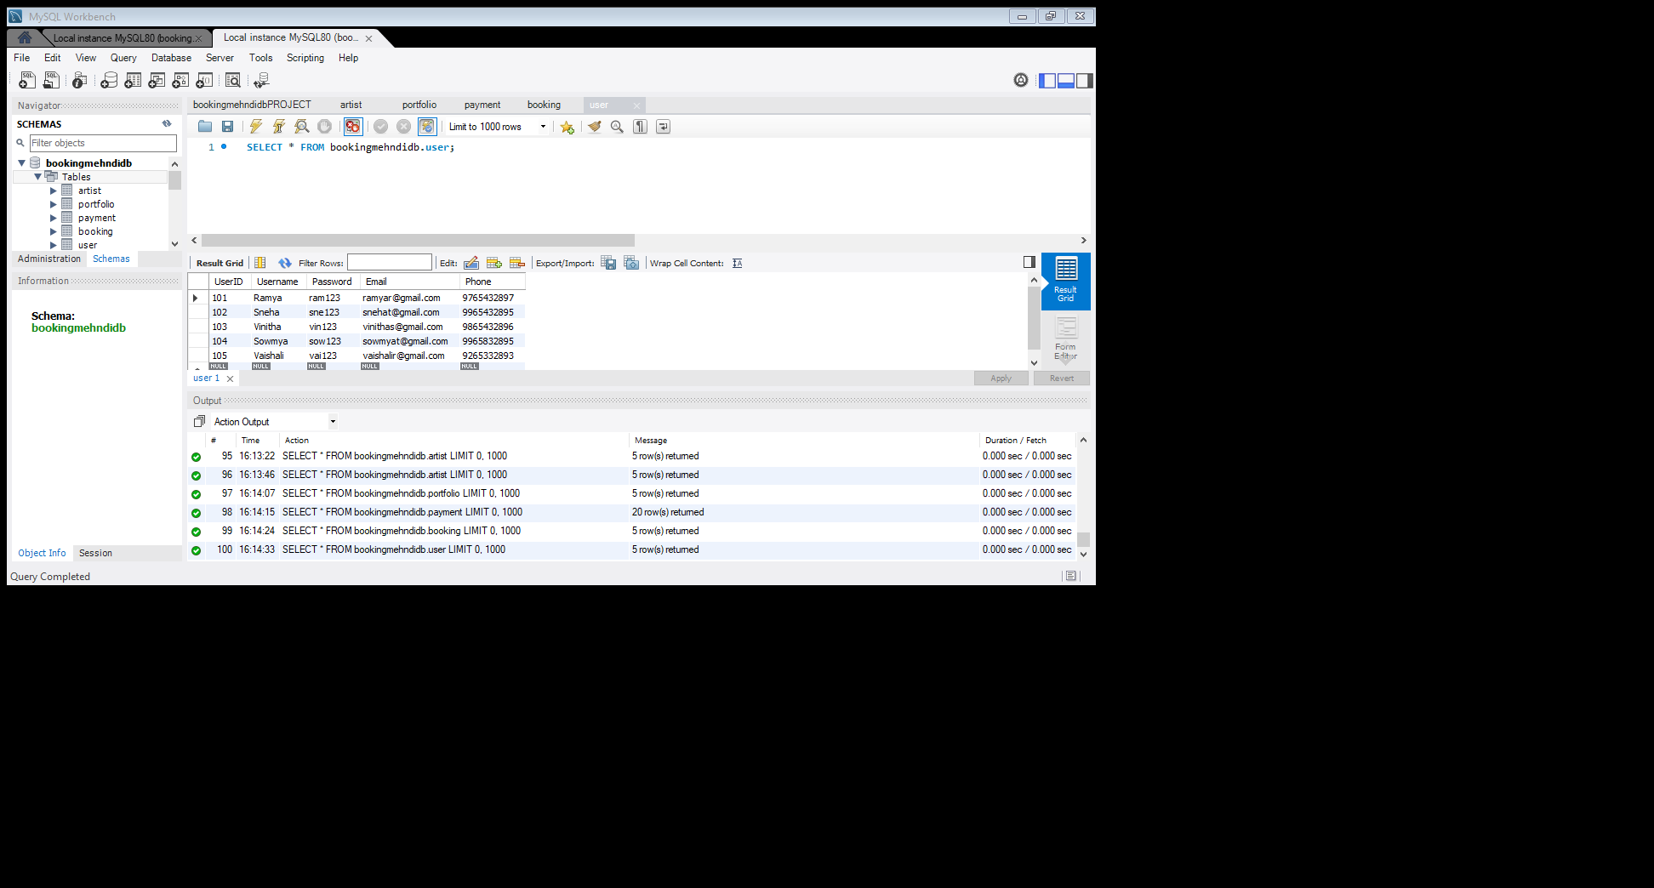

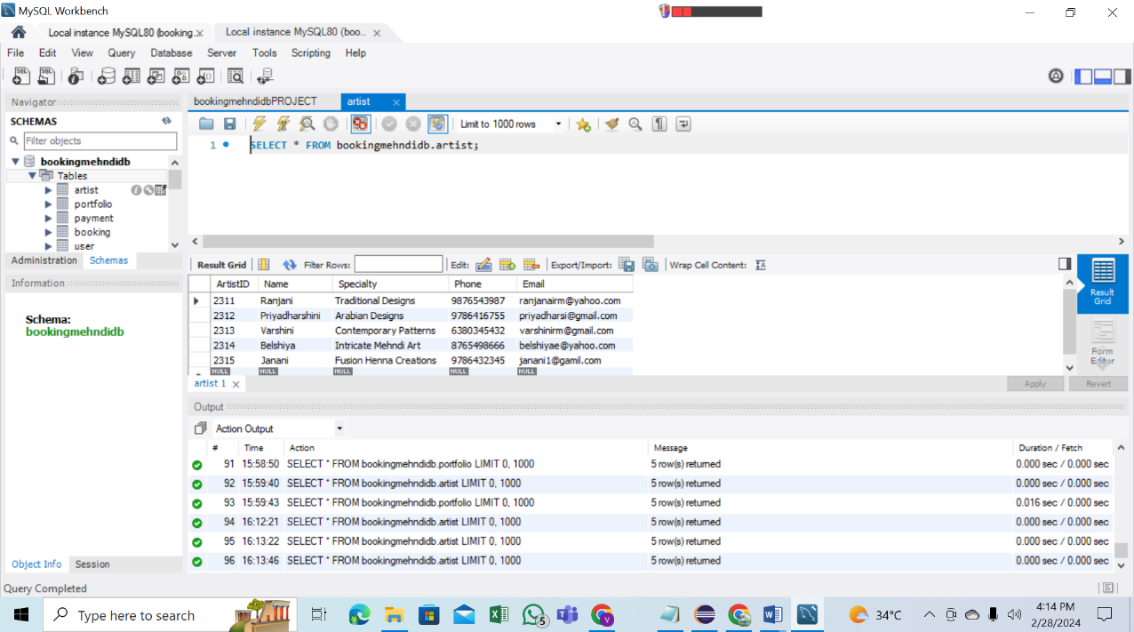

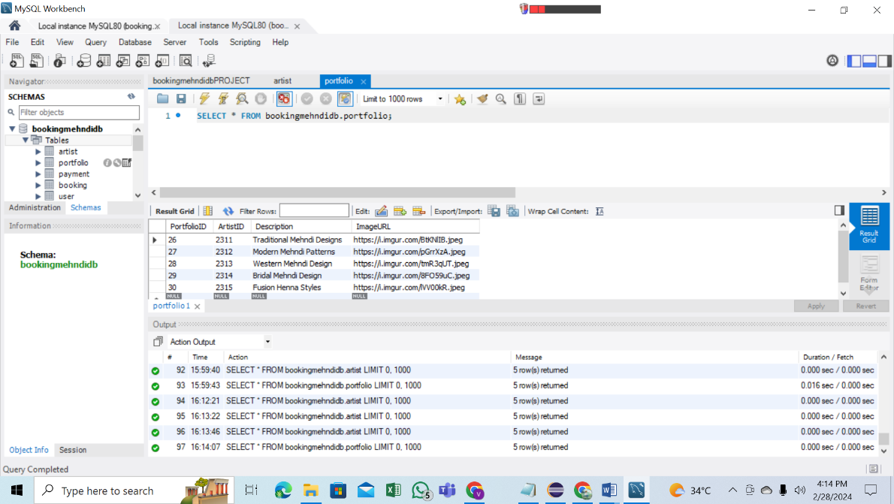

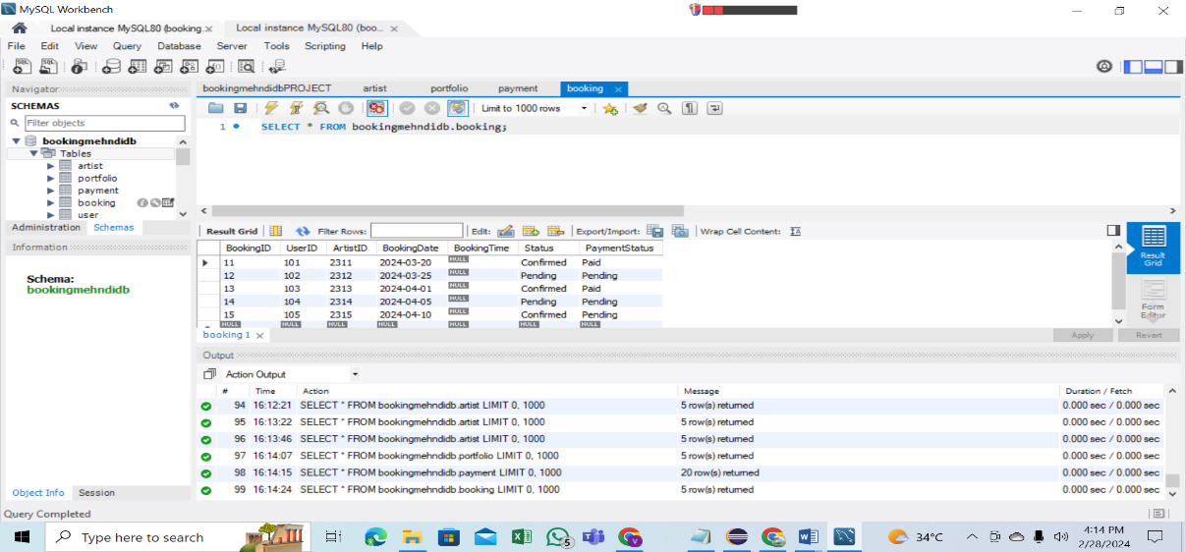

ER Diagram

